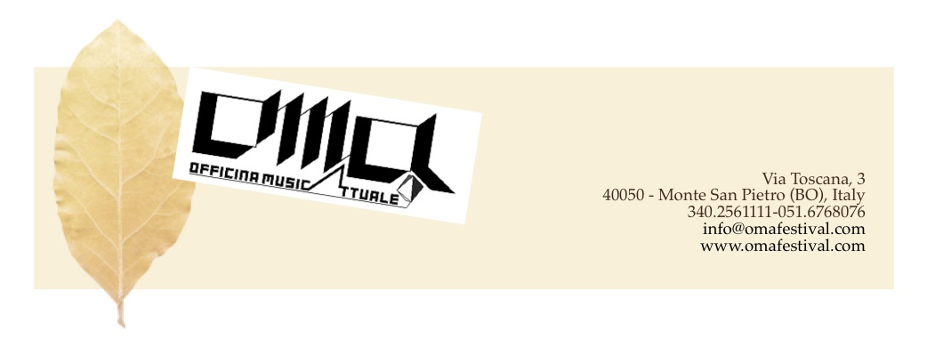
Name Surname/Publishing

Subject matter: author’s/composer’s redeeming declaration

for audio/video publication by work publishing

I undersigned Name Surname as composer-author, declare I have given my consent to audio-video recording, RVM-RF recording, film recording of composition entitled:

Name surname title, instrumentation, edition, date

recording effected on the day:

at/place:

on the occasion of the OMA Festival 2021

I declare that I have been informed by Agenda edizioni musicali, undertaking to produce relative music material, that the above said RVM-RF recording (or video and/or audio recording) will be included in the material produced by Agenda (audio CD or any other audio/video media); I also give my consent that the above said material can be used for any kind of diffusion, (by either adertising, promotional, commercial diffusion), by radio/TV on any public or private radio/TV network, and throughout sale networks).

I declare that the above said ownership/Publishing Company will be indicated on the produced material and on any other forms of diffusion among the ones above mentioned

I declare I will have nothing to claim from Agenda edizioni musicali excepting specific and separate agreements with the same one and here enclosed.
It is understood that Agenda edizioni musicali will use the above said material for the specified use, and that the exclusive ownership remains to me, the undersigned, as composer-author, and that I will be able to make use of the above said recording at my own will.

The Author’s – Composer’s Signature for the original Publishing Company

Publishing Company’s mark stamp

